**[872. Leaf-Similar Trees](https://leetcode.com/problems/leaf-similar-trees/)**

Solved

Easy

Topics

Companies

Consider all the leaves of a binary tree, from left to right order, the values of those leaves form a **leaf value sequence***.*

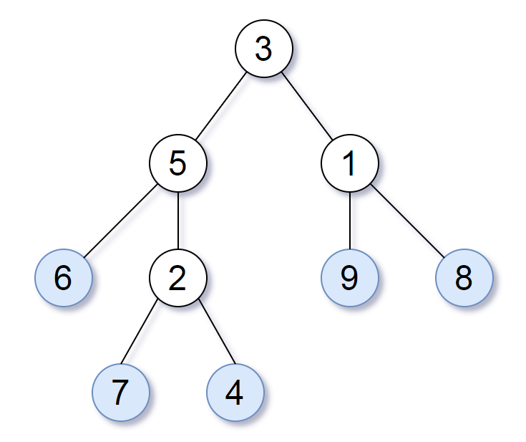

For example, in the given tree above, the leaf value sequence is (6, 7, 4, 9, 8).

Two binary trees are considered *leaf-similar* if their leaf value sequence is the same.

Return true if and only if the two given trees with head nodes root1 and root2 are leaf-similar.

**Example 1:**

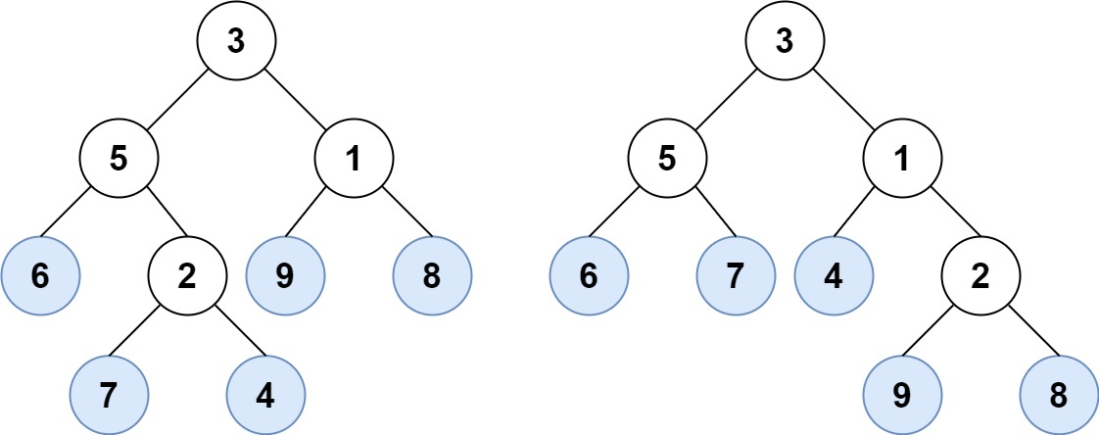

**Input:** root1 = [3,5,1,6,2,9,8,null,null,7,4], root2 = [3,5,1,6,7,4,2,null,null,null,null,null,null,9,8]

**Output:** true

**Example 2:**

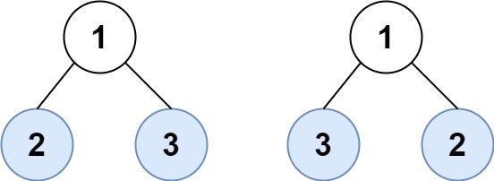

**Input:** root1 = [1,2,3], root2 = [1,3,2]

**Output:** false

**Constraints:**

* The number of nodes in each tree will be in the range [1, 200].
* Both of the given trees will have values in the range [0, 200].